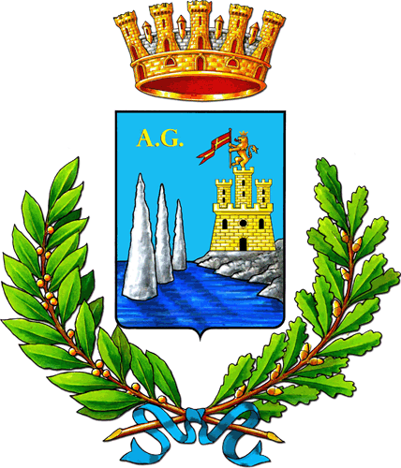

Acireale learning city - The Urban Centre

Acireale is a medium-sized city, belonging to the central-eastern urban system of Sicily. The city is part of the Metropolitan Area of Catania, and it possesses some peculiar characteristics that derive from its origins and history.

Between the nineteenth century and the first half of the twentieth century, Acireale played an important role in Sicilian cultural production, especially in training and education for the upper class, the so-called elite. This role has been guaranteed thanks to the presence of a large number of monasteries and buildings hosting numerous educational institutions, significant academies, art galleries, cultural associations, and so forth. In those years the city also played a key role in the economy of Sicily. It was one of the first cities that invested in thermal baths and tourism, excelling in artistic productions and high quality handicrafts, as well as engaging in cultural and commercial relations outside Sicily.

It was one of the first cities that invested in thermal baths and tourism, excelling in artistic productions and high quality handicrafts, as well as engaging in cultural and commercial relations outside Sicily

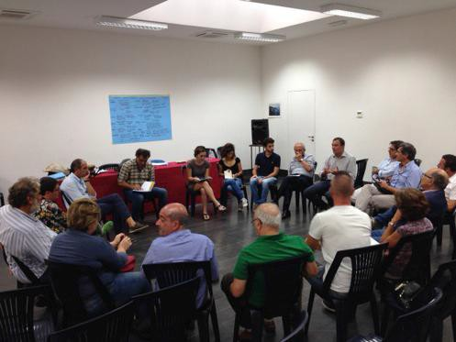
These dynamics lasted throughout the first half of the twentieth century, culminating in the '60s, a sort of golden age for Acireale, when its economy is literally fueled by the Lemon economy (production and export of lemons), together with the food industry and the rising business of concrete constructions. But still in those years, like in many other Italian areas, the city began to reduce its investments in culture, spending the majority of its financial resources in an insane urban growth. Moreover, in the last 30 years, the Concrete economy has produced devastating effects on the local productive habits and culture, transforming the local entrepreneurship. This insane process stopped only during the first years of the new millennium, after having consumed more than 30% of the municipal land, having transformed the natural environment, and having erased the majority of its historical and heritage landmarks, especially along the coast.

As a matter of fact, from the second half of the ‘80s, the city started experiencing a profound long-lasting crisis; on one side, due to the inability, for the entrepreneurial class, of adapting to the changing globalized markets; on the other hand, due to the loss of vital core functions, that have been transferred into the broader metropolitan context. But the crisis of Acireale is not only an economic one: it involves the identity of the city, reducing its human and social capital. These mechanisms have been reflected also on the political class that, for many years, has been committed to focus just on managing ordinary or emergency issues, with no capability of planning and designing the future development of the city, and no capability of generating any strategic visions for the medium-long run. This fact is in evidence, for instance, through the case of the elaboration of the Municipal Comprehensive Plan, a fundamental planning tool for the city, whose design process has lasted 35 years, and whose contents are not adequate for catalysing consistent forms of development, in relation with public funds and EU policies.

Within this background, something seems to have changed. The current municipal administration, elected in May 2014, has at the core of its political agenda to value the cultural system, implementing opportunities for improving human and social capital.

In this institutional context, there is an opportunity for Acireale: a new planning tool, defined as Integrated Plan for Ecological/Urban Reorganization and Socio-Economic Revitalization, seems to be a new start for the city of Acireale. The Integrated Plan is aimed at supporting environmental regeneration of the rural/urban areas, and the recovery/reutilization of existing buildings, in order to tackle the process of abandonment and degradation that characterizes the city, allowing a full regeneration. Along with these goals, the Integrated Plan targets other objectives. It aims to identify and to address the many forms of disadvantage and urban suffering in the city, the old and new forms of deprivation and poverty, focusing on the promotion and enhancement of behaviours based on cooperation and solidarity, boosting paths and processes of active citizenship.
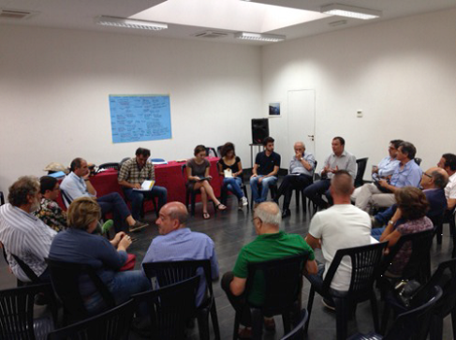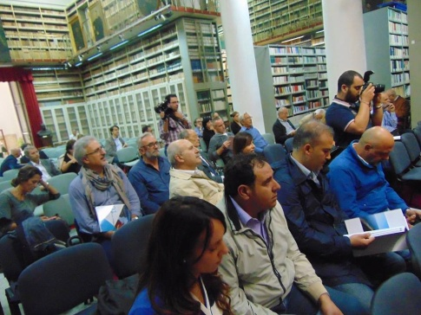

In order to design and implement this ambitious Integrated Plan, the City Council has set up a Planning office and requested the collaboration of the University of Catania. The partnership between the Planning office and the University of Catania has already led to the draft of a first document containing goals, methodologies and strategies to be implemented. The document has been presented to the city in December 2015. It contains: the identification of a first system of themes and policies related with the overall goal of the Integrated Plan; the identification of the various forms of knowledge and the analytical framework to put at the base of the Integrated Plan; the set of strategies and tools required for implementing the policies; the articulation of the preliminary procedures and temporal phases for the construction of the Integrated Plan itself; the identification of roles, actors and stakeholders involved in the different stages of the planning process.

The core of the strategy is to institute a cultural iconic place, both a physical and a virtual space, that local authorities will use for public debates, involving the broad local community in the decision-making process: the so-called Urban Centre. The Urban Centre has been designed as a tool for implementing more inclusive forms of direct democracy and catalysing practices of active citizenship. It is therefore an important functional pivotal aimed at facilitating the dialogue between civil society and local authorities, and at building opportunities for collective analysis and reflection on the main topics of interest for the city.

The Urban Centre is a physical and a virtual space: the physical space is set up for organizing meetings, conferences, workshops, seminars, exhibitions and whatever else can be useful to fuel the discussion and the direct dialogue amongst the various community members, and between citizens and local authorities. The virtual space is a website containing more sections. Some sections are aimed to build and feed the system of memory and knowledge related to the city and its rural lands. Also, users can consult policy documents and planning tools, related to regional and local governance for instance. Other functions are more related to nurture a participatory and proactive involvement of citizens: users are updated on activities in progress; they can participate in the debate about on-going events, express their points of view, and promote ideas or projects to share with other citizens.

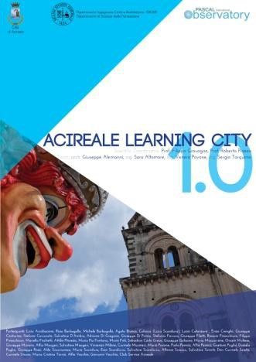
The full functioning of the Urban Centre is the great challenge of the new Integrated Plan. A challenge that has seen a first positive result with the project defined as Acireale Learning City. The project is aimed at developing an urban policy to enhance and to systematise the huge patrimony and the many cultural resources of Acireale, and it may be considered as a pilot project started thanks to the institution of the Urban Centre itself. In this path, the local authorities intend to make an important first step: entering Acireale in the international circuit of Learning Cities that propose to place at the heart of their development plan the culture as well as individual and collective learning mechanisms, in order to increase social and human capital and to create new opportunities of economic development for their inhabitants.

Through the project Acireale Learning City, the local authorities of the City also wanted to fuel the debate on contents and goals of the municipal Integrated Plan, which should promote the huge cultural heritage of the city. This path has allowed testing new forms of urban governance, a new and different structuring mechanism of public decision-making, never attempted before. The debate has been supported by participatory and inclusive practices to facilitate dialogue between all the components, between all the actors present in the urban scene, moving from the various resources and the human capital that enrich the city itself.

