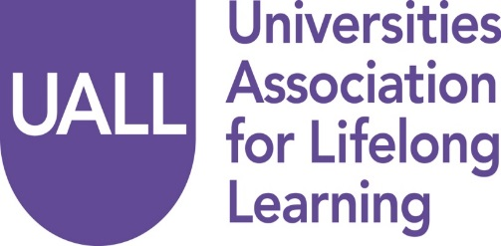

AGM Seminar

29 November 2018

Friends House, Euston, London

Please complete the booking form below by 19/11/2018 and return it to Alice Reynolds at: admin@uall.ac.uk. If you have any questions while completing this form, please do not hesitate to contact our administrator at: 0113 343 4105

Delegate Information
Name

Job title

Institution

Email

Address

Tel

Please indicate details of any dietary or special requirements

