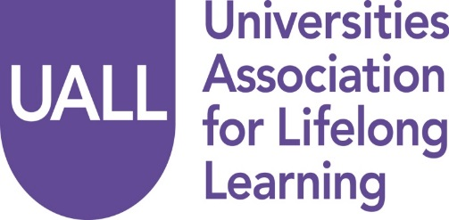

Booking Form

Annual Seminar
24 November 2016
Ambassadors Hotel, London
Social mobility and the mature learner: UK and international perspectives
Please complete the booking form below by Friday, 4 November 2016 and return it to Lucy Bate at: admin@uall.ac.uk. If you have any problems or questions while completing this form, please do not hesitate to contact Lucy Bate at: 01661 822185 or 07717 178 247.

Delegate Information
Name

Job title

Institution

Email

Address

Tel

Please indicate details of any dietary or special requirements

Fee: UALL members £90: non-UALL members £130

Payment to be made by cheque or BACS transfer:

Cheques should be made payable to Universities Association for Lifelong Learning
and returned to: Lucy Bate, Administrator, 20 Moor Lane, Ponteland, Newcastle upon Tyne,
NE20 9AD.

BACS details: Bank: Co-operative Bank, Olympic Court, Salford, M5 2QP
Sort Code: 08-92-50
Account No: 65025936
Account Name: Universities Association for Continuing Education

Alternatively, if you require your institution to be invoiced, please supply a Purchase Order No.
……………………………

