Child Sensitive Social Policies International Conference 2014
19th to 20th February 2014: Meikles Hotel, Harare

‘Towards a Child Sensitive Society on Africa’

The Department of Child Sensitive Social Policies at the Women’s University in Africa in collaboration with UNICEF Zimbabwe hosted the inaugural Child Sensitive Social Policies Conference. The main conference theme ‘Towards a Child Sensitive Society on Africa’ sought to explore the centrality of children in African contexts. It offered a multiplicity of children’s rights stakeholders an opportunity to revisit the Universalist and Relativist debates on childhood, with a view to finding common ground between child’s rights principles and cultural norms still viewed at odds with each other.
The conference was built on the growing partnership between UNICEF and the Women’s University in Africa, which started when the university, with support from UNICEF, started offering a Post-Graduate Diploma in Child-Sensitive Social Policies in January 2013. The post graduate course aims at creating a pool of national experts who are capable of analysing and influencing public policy in favour of children and vulnerable communities and increase national capacities for research in child-sensitive policies, providing policy and decision-makers with the data and evidence necessary for informed decision-making. Since its launch, 44 individuals drawn from Government departments and NGOs working in the development sector have graduated. (UNICEF Zimbabwe )
The Conference provided a platform for interaction on the marginalisation of vulnerable children and the effectiveness of interventions which address child poverty and social exclusion.
The Official Opening Address was delivered by the Honourable Dr David Parirenyatwa, Minister of Health and Child Care.
There were three sub-themes of the conference each of which involved a plenary session followed by a series of presentations addressing specific issues relevant to the particular sub-theme:
Track 1: Reconciling Child Rights and Culture
This sub-theme focused on the following issues:
- The boundaries of childhood
- Rites of passage
- Responsibilities of the child
- Child participation in an African cultural context
- Discipline and positive parenting
- Understanding the child rights language in African rural and traditional settings

Track 2: Social Inclusion, Poverty and Social Budgeting

This sub-theme focused on the following issues:
- Social protection for the vulnerable child
- Equal access to education
- Access to health and health care services
- Food security
- Homelessness of children
- Inclusion of children with disabilities

Track 3: Protecting our children from violence, exploitation and abuse
This sub-theme focused on the following issues:
- Gender based violence against children
- Access to contraception for sexually active children
- The effects of migration on the children themselves
- Protection of children in trouble with the law and as victims of crime
- Electronic and media risk
- Intergenerational sexual relationships between adults and children
- Psychosocial support

Each of the sessions involved interesting, informative and thought provoking presentations from a range of African countries including Namibia, South Africa, Uganda and Zimbabwe featuring presenters from universities, civil organisation, NGOs and other stakeholders including UNICEF. A number of poster presentations were also on view highlighting some of the ongoing work aiming to address issues raised in the conference.
In addition, and given the focus of the Conference, it was good that the voices of children themselves were heard in the form of a special Children’s Plenary session on the second day of the conference. Entitled ‘Listen to me and take me seriously’, children of diverse backgrounds and abilities took the opportunity to address and engage with the conference delegates to air their views on a number of the areas covered in the conference sub-themes. The poise and confidence of these children and the quality of their contributions not only in the Children’s Plenary but also in contributing to the question and comments sessions following each session suggest that there is a bright future for their generation if they are given the opportunity.
Finally, the Closing Address was given by the Deputy Minister for Primary and Secondary Education Professor Paul Mavhima

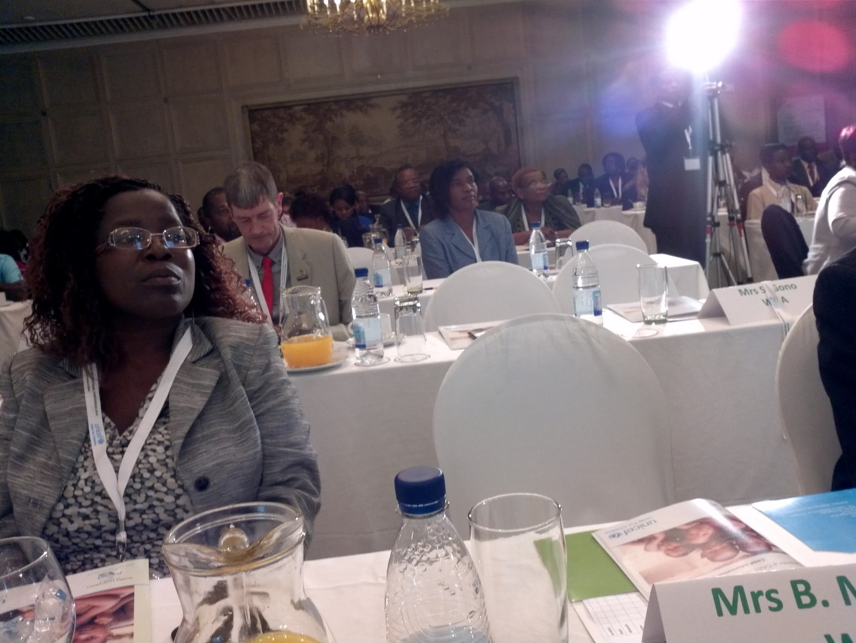
Conference delegates
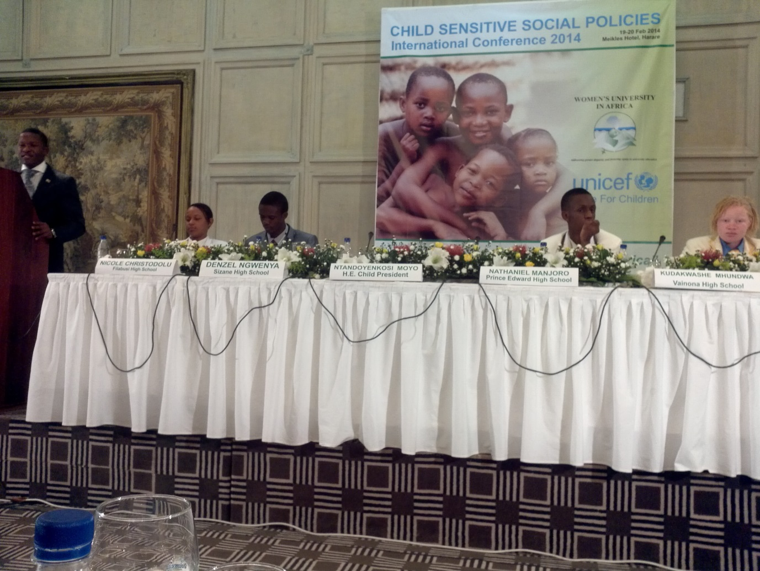
The Children’s Plenary
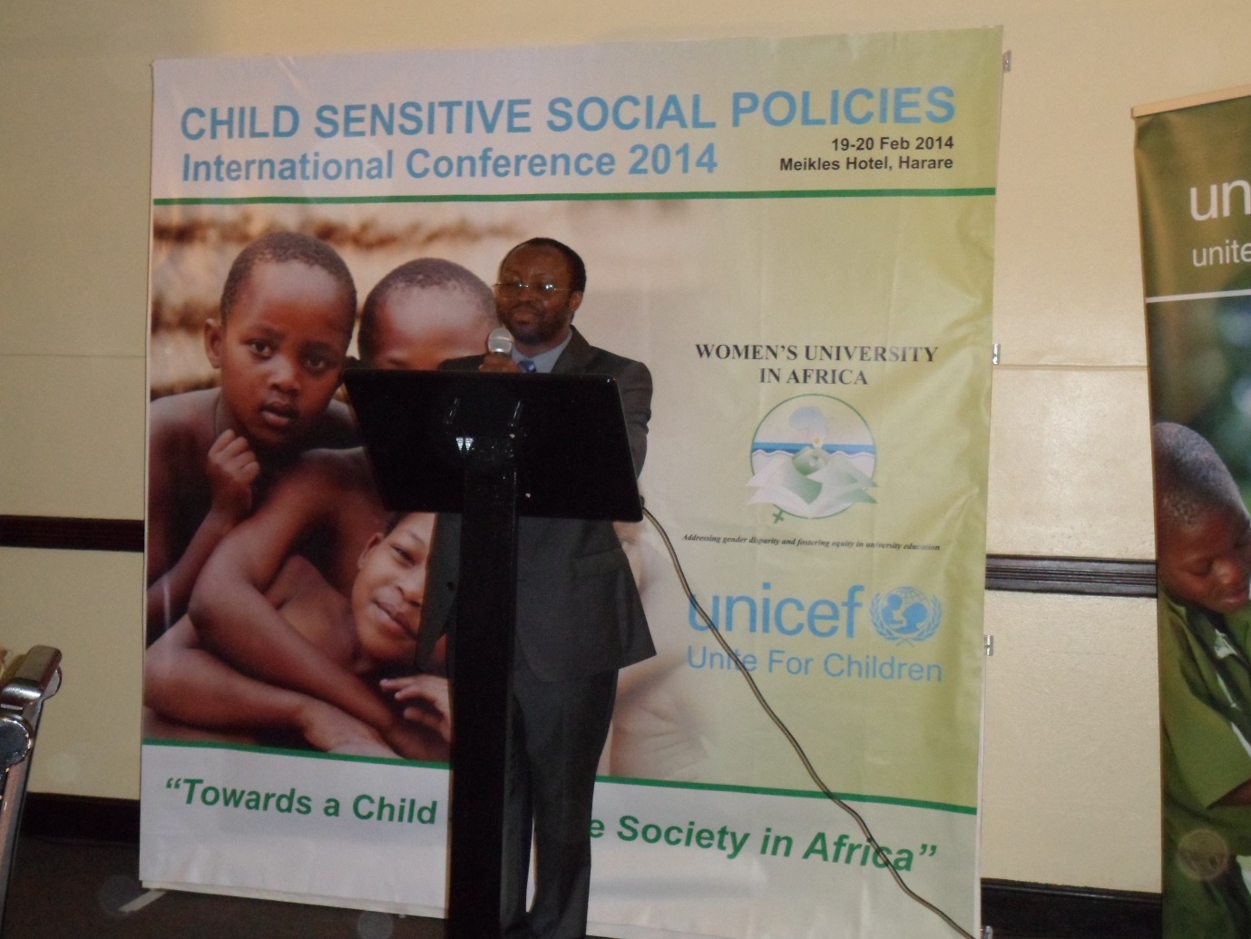
Professor Charles Nherera, Pro-Vice Chancellor of the Women’s University in Africa (WUA) at the Conference Dinner.

