Special call for applications from early career access / widening participation practitioners and researchers

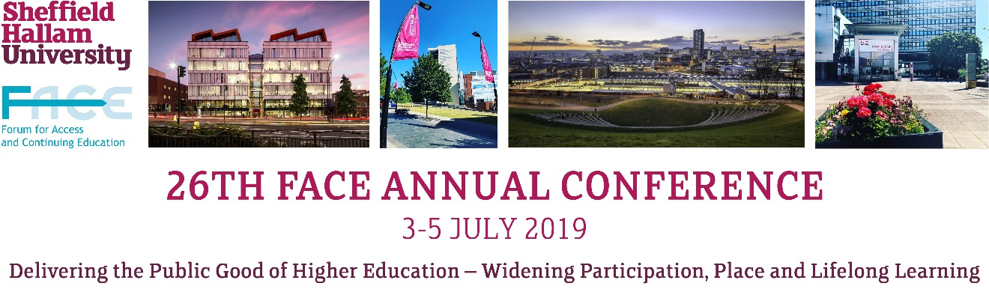

FACE is now delighted to invite applications for a sponsored place at the 26th FACE Annual Conference, hosted by Sheffield Hallam University,
3rd -5th July 2019.
This includes all Conference fees and access to the social programme. Accommodation and travel expenses are not included.

Priority consideration will be given to those applications that meet the following criteria:

- Presenter is a practitioner or researcher (including postgraduate study) in access / widening participation for less than two years.
- Presenter is employed or enrolled at an institution with current FACE membership
- Presentation addresses one or more of the Conference themes:

- Public good of Higher Education: Exploring and understanding the wider benefits of an inclusive Higher Education system
- Widening Participation: Challenging and innovative approaches to access and success in HE and beyond
- Place: Examining the impact of place and context on HE access and participation
- Lifelong Learning: The role of HE institutionally, regionally, nationally and internationally in creating and delivering lifelong learning opportunities

For further information on the Conference please go to the Conference website at http://conference.face.ac.uk/

Applicants should submit a title and abstract for a Conference paper which will be reviewed by a special panel of the FACE Executive. The successful author will be invited to attend the full Conference, to give a full Conference presentation and submit a full paper for publication in the Conference publication (subject to peer review).

Application:

Please complete the following:
First name
Surname
Name of college / university
Email address
Phone number
Role
How long have you been in this role and how does it relate to the criteria?
Proposed conference paper title
Which conference theme(s) do (es) your paper relate to?
Proposed conference paper abstract
(Max. 500 words)
How does your conference paper relate to the criteria?

