ESREA – European Society for Research on the Education of Adults
Life History and Biographical Research Network
The Annual Conference will held in Magdeburg, Germany
at the Otto-von-Guericke-Universität Magdeburg www.ovgu.de
from Thursday 6th to Sunday 9th March 2014
Conference Announcement and First Call for Papers
“Before, Beside and After the Biographical Narrative”
The ESREA Life History and Biography Network has been active and influential over many years. It offers a forum for a wide range of researchers, for those new and starting out in the field as well as for experienced and regular participants in the network, and it draws on differing disciplinary backgrounds. It includes researchers and doctoral students from every part of Europe, north, south, east and west, the Americas, Africa and beyond. The Network first met in Geneva in 1994 and has provided the basis for diverse and influential publications, as well as for major collaborative research projects and many other forms of collaboration.
The network has explored in the last years‘ conferences (e.g. Milano, Vaxjö, Geneva, Odense and Canterbury) areas of research and practice in life history and biography/autobiography/auto/biography that have been neglected perhaps (the body, wisdom) and those which are of growing interest: emotions, words, interdisciplinary research, agency and structure.
The field(s) of life history and biography research are very much characterised by schools of practice, by national boundaries. The convenors and the organizer of the 2014 conference recognize this and wish to explore the possibilities of crossing some of the boundaries of practice, some of the frontiers dividing country-specific cultures of research, crossing, too, some of the persistently obstinate linguistic boundaries/barriers that, we feel, impoverish the debate that is central to a vigorous field of research such as ours patently is.
Thus, the Magdeburg conference wishes to concentrate both on the contents and the results of our research, as well as on how we do our work. We would all agree that the narratives – in the widest sense of the term – that we elicit, collect, listen to, record, film, transcribe, analyse and communicate (and co-construct) are located at the very core of our theory and practice. All the more reason, we feel, to take this opportunity to turn our attention to what "goes in" to the biographical narratives in our research.
For this reason we have chosen the title "Before, Beside and After the Biographical Narrative" with the aim of opening up a discussion around the "before" and "after" of people's biographical processes, that is, turning our attention, besides to our more visible practices, as well to that which isn't protocolled, transcribed, described, or presented and yet which is in the stories, and is an intrinsic part of the narratives. In attending to different aspects of the biographical experience - voice, bodily expression, relationships, silences, signs, unconscious processes and so on - we can ask important questions about our perspectives, our methods, our writings, our discussions.
The many ways of doing life history and biography research, and a deep theoretical and epistemological reflection on the the practice of biographical research and biographical narratives, will be a central focus of this meeting.
This means that, besides the usual presentations on the advancement of life history and biographical research in the broad field of adult education and lifelong learning, we particularly welcome proposals for workshops / demonstrations, open round tables and symposia, papers or posters on methodology, methods, data analysis, etc.
We invite contributions from
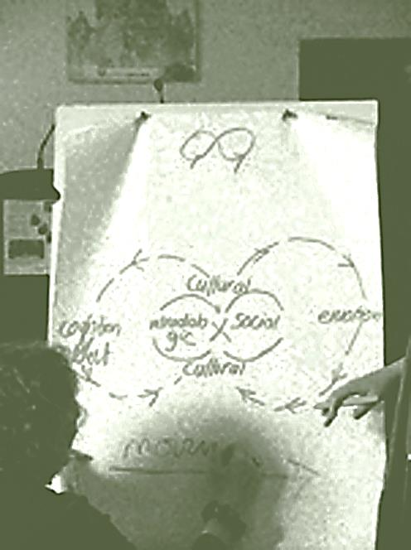
- Biography + therapy, biographical method + counselling, auto/biographies, narratives and psychoanalysis
- Videography + medialisation of biographies
- Autobiographical writing + biographies of learning
- Visual Art, photography + narrative methods
- Documentary methods
- Literature, social media, discourse methods
- Mixed methods, CAQDAS
We also welcome presentations on research where biographical methods are used to answer questions touching on all that goes before, beside and beyond narratives. These may include, for example:
- Silence and learning in adult life (and research)
- Themes of voice and recognition in different groups and contexts
- The building and transformation of relationships (in life and research)
- Care, health, and learning
- Human becoming and the quest for wisdom
- Participation and political engagement
- Stories of loss, pain, and challenging lives
- Unconscious processes, narratives and the relationships constituting research
In our conference, we want to help create spaces for dialogue, demonstration, reflexivity and discovery. There will be a series of keynotes from internationally renowned colleagues, dialogues /round tables, alongside individual papers and symposia, focusing on our theme of before, beside and beyond the biographical narrative and the importance of this in researching learning lives.

Guidelines for submission of paper abstracts/ proposals for symposia / workshops
Abstracts should be submitted by 30th September 2013 to the conference organiser at esreabios@ovgu.de
Your paper proposal should have no more than 500 words and should be in Times New Roman, 12 points.
Please send on a separate sheet your professional / personal data (name, institutional affiliation, phone and email).
If an abstract is submitted by more than one author, one of the authors must take on the responsibility for their co-authors for all communications with the conference organiser.
The proposals for papers, symposia, workshops, posters will be blind reviewed by the Scientific Committee.
Acceptance will be announced by
31st October 2013
Final papers (3000 – 5000 words) should be submitted by email to Rob Evans at esreabios@ovgu.de by
10 January 2014
Detailed Guidelines for submission of papers will be made available on the conference website at a later date.
Conference languages: English / French /German
ESREA's language policy is understood as being inclusive. Abstracts for the peer-review process must be in English or French. Though Papers will as a rule be in English, both Papers and Presentations in the conference will be welcome in French or German as well as English. In the case of Papers in languages other than English, where possible, short (1000-1500 word) summaries in English should be provided.
For French, German, Italian speakers and naturally for all others: it is suggested that slides to the talk (at least in part) be in English or, if possible, bilingual. English speakers are asked, too, where possible, to provide bilingual versions of their slides. At the conference there will not be any form of professional translation, but from experience we know that there are a number of colleagues who are willing and able to help and facilitate dialogue. Tolerance, respect, mutual support and curiosity will do the rest.
Just as all participants are asked to show patience and tolerance – as well as interest and curiosity - where a language other than their own is used, it is equally important to recognise that speakers requiring some element of translation or explanation must accept that they can say less in the allotted time and that they should plan for this – perhaps by providing essential information in the form of a hand-out, for example.
Oral presentations should be up to 25 minutes and there will be 20 minutes additionally for debate.
Conference Fees and registration / Conference Dinner
EARLY BIRD REGISTRATION (until 15th January 2014)
ESREA members: € 150
Non-members: € 200
PhD/Research Students: € 75 (a limited number of bursaries for PhD students will be available)*

FULL FEE (after 15th January 2014)
ESREA members: € 180
Non-members: € 230
PhD/Research Students: € 100

Conference Dinner: € 40
The conference registration fee includes:
Participation in the work of the conference plenary and parallel sessions
Working documents for the conference
Refreshments and lunch during the breaks from the beginning of the conference Thursday afternoon to Sunday morning and the buffet meal on the first evening.
ESREA will be offering some bursaries for doctoral students. The bursaries exist in order to give some support to a small number of graduate-students to participate in the conference. There will probably be three bursaries for this conference. In order to be able to apply for a bursary, the applicant needs to be
- a graduate student (currently doing a Doctoral or Master’s Degree)
- in addition, the applicant must be a member of ESREA (either an Individual Member or a member through their institution’s membership)
- the applicant must submit a paper to the conference
The bursary is at the moment 300 Euros/person and is designed to cover parts of the costs for travel expenditures and/or accommodation during the conference/meeting. Details of the ESREA bursaries will be provided on the conference website.
*Individuals who hold a position at a university, including PhD or other doctoral students who are employed full-time by their university, are expected to pay the full fee. Those who register as a PhD student need to be able to show proof of their status.
For questions and expressions of interest in the meantime, please contact the Conference Organiser at esreabios@ovgu.de or the Convenors of the Network:
Professor Linden West (convenor of the network)
Canterbury Christ Church University
linden.west@canterbury.ac.uk
Professor Laura Formenti (convenor of the network)
Università di Milano Bicocca
laura.formenti@unimib.it
Organising Institutions
ESREA (European Society for Research on the Education of Adults) www.esrea.org
ESREA promotes and disseminates theoretical and empirical research on the education of adults and adult learning in Europe through research networks, conferences and publications. It was established in 1991 as a scientific society which provides a Europe-wide forum for all researchers’ engaged in adult education and learning. Today it has more than 400 members (individual and institutional) throughout Europe. It comprises a series of research networks that hold annual seminars for the exchange and scientific opened debate of research results and to encourage publications.
Sprachenzentrum/Language Centre, Magdeburg University
Otto-von-Guericke-Universität Magdeburg www.ovgu.de
As indicated above, full details about writing and submitting papers, about fees and PhD bursaries, registration, about the Magdeburg venue and accommodation in Magdeburg will appear soon on the conference website (www.esreabios.ovgu.de) and on the official ESREA website (www.esrea.org) under 'conferences'.

