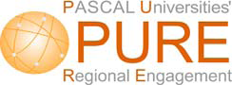

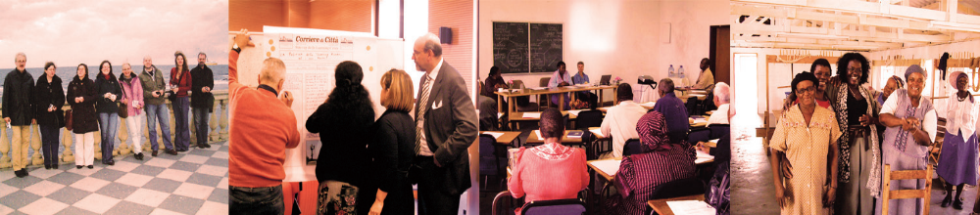

BRUSSELS 19TH AND 20TH May, 2011

“Regional Development and Higher Education – the Next Decade”

REVIEWS what has been happening, globally and within Europe, to enhance the contribution of higher education institutions to the development of their regions;
EXAMINES how to plan for a stronger contribution in the current decade; PROVIDES GUIDANCE on how to gain from international networking in this area
-----------------------------------------------------------------------------

The PASCAL Universities Regional Engagement Project (PURE) has now completed its pilot phase in working with public authorities and their higher education institutions in order to explore how best to develop useful and practical working partnerships.

This meeting is an opportunity to discuss, with the PURE team and with PURE client regions, how the project developed, what it learned and how it might apply to your public authority, your institution or your professional body.

With the input of significant figures from public authorities, from European institutions and from researchers and practitioners with wide experience of tackling the demands placed on public bodies the PURE meeting will provide insight into how engagement may best developed, what tools are best suited and, most significantly, how it may be progressed in a climate of austerity.

CONFERENCE PROGRAMME

Thursday 19 May

14.00: Welcome - Jarl Bengtsson, Chair of PASCAL, and Erik Andersson, Director, Jämtland County Council Institute of Rural Development, Sweden
Session 1 ‘Governance and the Needs of Regions’ (Session Chair - Mike Osborne, Executive Director – PURE and PASCAL Co-Director, Europe)
14.05: Introductory Address - ‘Why Universities Matter to Regions – managing innovation and development in a leading English Regional Authority’ Alex King - Deputy Leader, Kent County Council, England
14.30: Keynote Address – ‘The Region and the European Community – the past twenty years and the next decade’ Silke Toenshoff, Head of Unit, Committee of Regions EU
Questions and Discussion
15.30-16.00: Coffee
Session 2 ‘Regions and Their Learning – reports from regions in the Pascal PURE Project’ (Session Chair - Chris Duke, Academic Director – PURE)
16.00: ‘’Coalface’ reports from ongoing regional projects’
A panel of representatives from three PURE regions discusses what they seek from the Project, how international networking and the 2nd Peer Review Visits help, and what in particular the region is doing to make engagement work better.
Devon and Cornwall, England; Glasgow, Scotland; Helsinki, Finland
Open Discussion
17.00: ‘Reports on innovation and development after completing the PURE cycle and continuing with new work’ A panel of representatives from several PURE regions explains how taking part strengthened their regional development work and how they are taking this forward, using the PURE network and website as appropriate
Melbourne, Australia; Flanders, Belgium; Varmland, Sweden; Northern Illinois, USA
Open Discussion

19.30: Dinner (location to be advised)

Friday 20th May

Session 3 ‘Innovation and Future Development’ (Session Chair – Bruce Wilson, PASCAL Co-Director – Australasia)
09.30: Keynote Address – ‘The Region, Innovation and the OECD – the past twenty years and the next decade’ (to be advised – OECD representative)
Questions and Discussion
10.30–10.45: Coffee
Session 4 ‘Engagement between Public Bodies and Higher Education’ (Session Chair – Bruce Wilson)
‘Findings from the PURE Project and lessons for the future’ Chris Duke and Mike Osborne, PURE, with other contributors
Problems and barriers to engagement, priority policy areas for regions, solutions at regional, national and institutional levels. This session draws on work for a monograph being published by Manchester University Press. It allows open discussion of key issues, challenges and opportunities for future work by regions in the new global policy environment
Questions and Discussion
12.30-13.30: Lunch
Session 5
13.30-14.30: ‘Other Perspectives’ (Session Chair - Erik Andersson),
Perspectives from other regions – challenges, needs, aspirations. Panel contributions from regions interested or involved in this work, drawn from among Macedonia (Greece), Brittany (France) Munster (Germany), Tampere or Jyvaskala (Finland), Rekyavik (Iceland), Stockholm or Skåne Västmanland (Sweden)
14.30-14.45: Coffee
Session 6
14.45-16.00: Panel Debate and Concluding Open Forum (Session Chair -Jarl Bengtsson)
Challenges for Governance in an Era of Financial, Ecological, Political and Existential Crisis – what should the regions be doing?
Panellists include Hans Schuetze, PASCAL Executive, former General Manager of the Lower Saxony Agency for Technology Transfer and Innovation (NATI), asking whether universities adapt and engage in a regional role in their own time of crisis, and Josef Konvitz, OECD, on innovation and the governance of place
16.00: Close of Conference
WHERE IS THE CONFERENCE?

At the Mid Sweden Office, 3, Avenue Palmerston, Brussels 1000, Belgium. The Conference begins at 14.00 on the 19th of May and ends at 16.00 on the 20th. The venue is easily reached by Metro from Brussels railway stations. Full joining directions will be given to those registering.

WHAT IS THE CONFERENCE FEE?

250 Euros per delegate: which includes the cost of Conference papers, break refreshments, the Conference Dinner on the first day and Lunch on the second. Accommodation is NOT included and must be organised by delegates themselves. The full fee must be paid in advance at the time of registration. A Registration Form may be found on page 4.

NOTE: PURE 2011 participating regions (i.e. those entering on a new PASCAL contract from 2011 onwards at Service Level 2 and above) may send one delegate (who should still register to attend) without a fee being charged.

WHO SHOULD ATTEND?

Policy makers, Planners, Strategy Managers, Representatives of Public Bodies and Authorities, Researchers, Representatives of Educational Institutions and Authorities: and anyone involved in designing and implementing social development which concerns regions and city metropolitan areas and their higher education institutions.

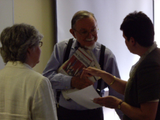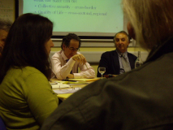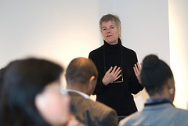

CONFERENCE REGISTRATION
Please complete and return by e-mail, regular mail or fax (details and address below).

1. Personal details

Family name:- First Name:-

Title:-

Organisation (and address):-

Telephone:- Fax:- e- Mail:-

Special dietary requirements (for lunch and dinner):-

2. Payment (please circle appropriate category) – 250 Euros

a. Free Place (PASCAL 2011 Service Level 2 and above)

b. Credit Card/ Debit Card (please circle the chosen method)

Card Number
___ ___ ___ ___ ___ ___ ___ ___ ___ ___ ___ ___ ___ ___ ___ ___ ___ ___ ___ ___

Start date (essential) Security Number (essential)* Expiry date (essential)
_________________ _______________________ __________________
* The Security Number (or ‘VPN’) is the last three digits of the number in the Signature Panel on the back of your card
Issue Number (where appropriate)
_________________

c. Bank Giro Credit Transfer (BACS)

To use BACS payment you must attach a ‘Purchase Order’, addressed to ‘University of Glasgow’ at the address below, together with the address of the institution to which our Invoice will be despatched. We will then issue an invoice and your institution will be able to make direct payment using the reference details provided on our invoice


www.pascalobservatory.org

FOR ALL ENQUIRIES
CONTACT:
The PURE Office
The PASCAL International Observatory
Room 614, St. Andrews Building, University of Glasgow,
11, Eldon St.,
GLASGOW, G3 6NH SCOTLAND
(0044) (0) 141 330 1833
pureadmin@educ.gla.ac.uk

