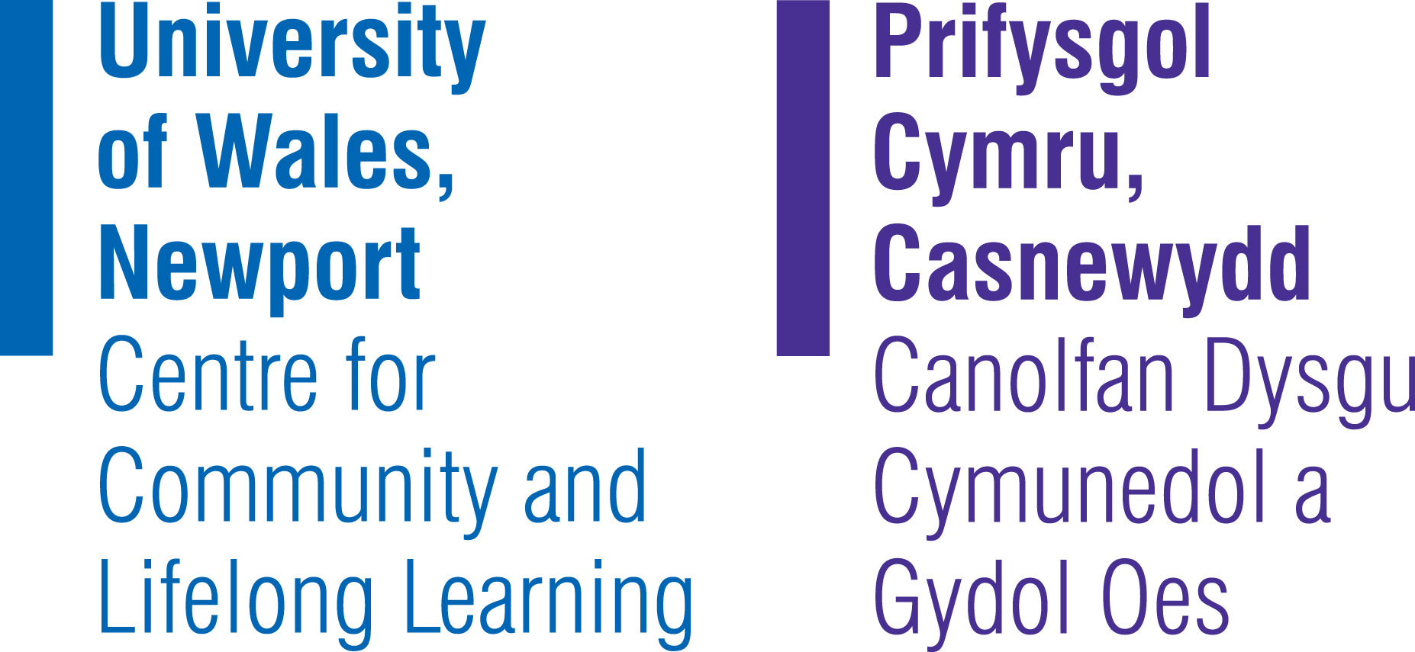
Call for Papers
Regeneration and Learning.
Continuity, Change and Community.
October 20th to 23rd 2008

The Centre for Community and Lifelong Learning at the University of Wales, Newport is holding an international conference which will be located at the Celtic Manor Hotel, the home of the 2010 Ryder Cup.
The transformative potential of regeneration is identified in policy, nationally and internationally, as an instrument which can be both visual and psychological, raising aspirations, improving skills and improving the environment whilst introducing dynamism to an area. The goal of the Regeneration and Learning Conference is to provide academics, professionals and practitioners working in related fields with the opportunity to come together and learn from each other, acknowledging the diversity and cross disciplinary nature of the regeneration agenda.

The themes of the conference will centre on
  - lifelong learning
  - education as a tool for regeneration
  - building social capital and social cohesion through regeneration
  - sustainable regeneration and education

Submission of abstracts may include reporting on policy development, innovative practice, research in progress or completed research, methodological issues, theoretical issues or conceptual issues in the following topic areas.

The role of higher education in the regeneration process

Families learning together

A vision for a new 14-19 landscape

Inclusive community regeneration

Addressing disadvantage and exclusion

The challenge of re-skilling communities in de-industrialised regions

The role of employers in raising skills levels for regeneration

Social entrepreneurship, necessary skills and support needs

Social enterprise as a means of combating social exclusion and reducing poverty

Working with SMEs, industry and business

The effectiveness of regeneration in enhancing social capital

Lessons from International Development

Other relevant case studies and research

The Regeneration and Learning Conference welcomes the following types of submissions:

- Research Papers
Completed research papers covering any of the listed themes or related topic areas.
- Abstracts
Abstracts of completed or proposed research in any of the topic areas listed above or related areas.
- Case Studies
Case studies in any of the topic areas listed above or related areas.
- Work-in-Progress Reports or Proposals for Future Research
Incomplete research or ideas for future research in order to generate discussion and feedback in any of the topic areas listed above or related areas.

- Reports on Issues Related to Teaching
Reports related to innovative provision and pathways or research related to teaching and pedagogy in any of the topic areas listed above or related areas.

Format of Presentations:
Paper sessions will consist of three to four presentations in a 90 minute session. The session will be divided equally between the presenters.
Workshop presentations will be given a 60 minute session.

Panel sessions will provide an opportunity for three or more presenters to speak in a more open and conversational setting with conference attendees. Submissions for these 90 minute sessions should include the name, department, affiliation, and email address of each panellist in addition to a description of the presentation or topic area.

Poster sessions will last 60 minutes and consist of a large number of presenters. Poster sessions allow attendees to speak with the presenters on a one-to-one basis.

Submission of Abstracts
Abstract submission deadline: | 15th August 2008
Notification of paper acceptance | 30th August 2008
Abstracts should be between 150 and 300 words.
All abstract should clearly give
- Name and full contact details for all contributing authors
- A clear indication of which conference theme the submission relates to.
- Whether the proposal represents a presented paper, a workshop or a poster.
- The full title of the paper.
- Full citation of all authors / contributors involved.
- ALL AUTHORS should include an annotated biography of no more than 100 words. The biographical description for each contributing author should include information on her/his field of study, main research interests and any key publications.
Please submit abstracts by e-mail to the conference co-ordinator valerie.french@newport.ac.uk
or post to:
Valerie French (Regeneration and Learning Conference Coordinator),
Centre for Community and Lifelong Learning,
University of Wales, Newport,
Caerleon Campus,
Lodge Road, Newport
NP18 3QT
Telephone: +44 (0) 1633 432866

