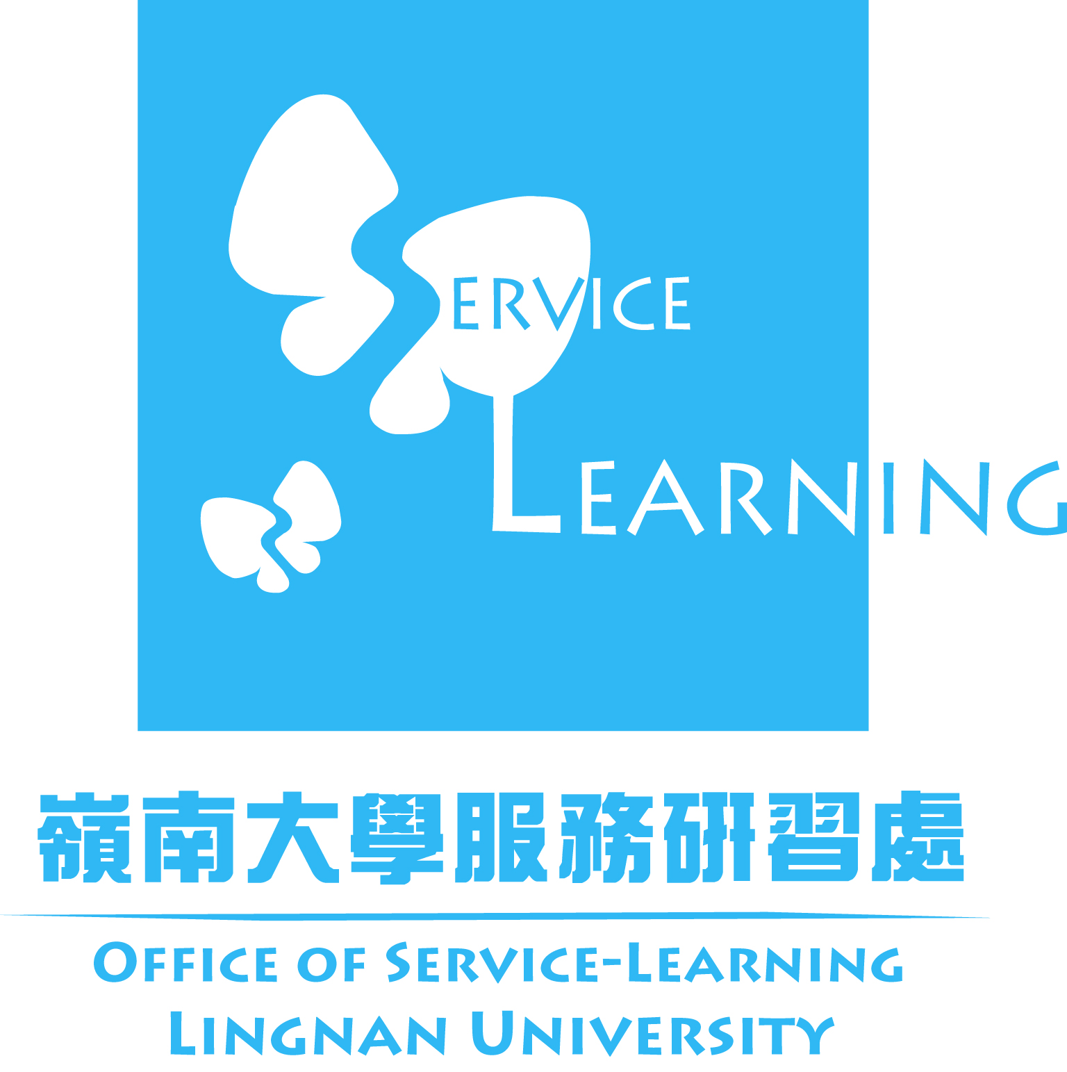


The 4th Asia-Pacific Regional Conference on Service-Learning
“Service-Learning as a Bridge from
Local to Global: Connected World, Connected Future”
Service-Learning Award 2013 Submission Form

Guidelines for Service-Learning Award 2013
- Proposal and Submission Form shall be submitted and presented in English.
- The length of the proposal must not exceed 2000 words and it should be submitted to the committee by 31 March 2013.
- Handwritten proposal and submission form will not be accepted.
- Result will be announced in mid-April, and the winners will be notified individually.
- Winner must register for the conference.
Personal Information
Title (please ✓) |  |  |  | Prof. |  |  | Dr. |  | Mr. | Mrs. | Ms. | Others (specify if so chooses): __________________
Surname/Last name: |  |  |  |  |  |  |  |  |  |  | Given name/First name:
Position |  |  |  |  |  |  |  |  |  |  | Department
Organization /Institution /Society:
Country: |  |  |  |  |  |  |  |  |  |  | Telephone:
Fax: |  |  |  |  |  |  |  |  |  |  | Email:
Have you registered for the conference? : Yes Not yet

Proposal Details

Category: (Please choose one of the following categories for your proposal)*

Social Inclusion Ageing Poverty

*Please refer to the www.ln.edu.hk/osl/conference2013/SLaward.html for the details

Author Declaration

I do agree that the proposal will be posted on the conference website.

Submission Deadline: 31 March 2013

For enquiry, please contact the Conference Secretariat:

Office of Service-Learning, Lingnan University

Email: oslconf@ln.edu.hk

