Scenario 1  Between Hope and Despair   | 

You are interested in participating in a Grundtvig course. In the Grundtvig course database you find a variety of courses, of which one really appeals to you. The course is about making use of the urban environment as a means to enliven and effectuate teaching the English language in schools. You have great expectations of it.

YOUR CITY AS A PROJECT FOR TEACHING ENGLISH IN SCHOOLS
Reference Number | : CZ-2011-079-007
Start Date | : 12/06/2011
End date | : 18/06/2011
Location | : Prague - Czech Republic
Organising Institution | : ITC - International TEFL Certificate

Throughout the weeks and months, before the course actually starts, you speak frequently with your colleagues about your expectations. During these conversations you’re getting a clearer picture on what the course should be like or should not like. You decide on organizing a preparatory meeting with a group of people who will attend the same course. During the meeting you discuss with the group what you hope the course will offer, and or not offer to you . You will order the ideas of the group in two columns.

 | Which characteristics of a good course do you hope to discover and come across? |  | What do you hope that certainly will not happen?
Scenario 2
Between Pizza and Pasta

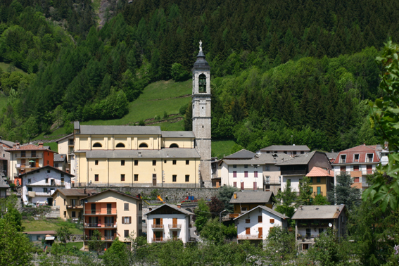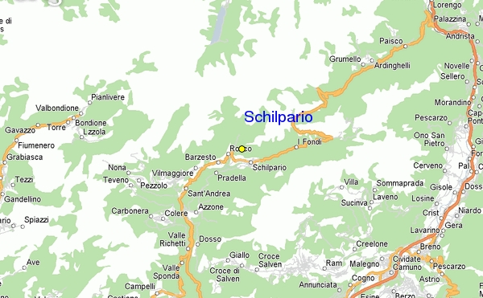

Title | : Taking learning outdoors!
Reference Number | : UK-2009-935-001
Start Date | : 11/06/2011
End date | : 17/06/2011
Location | : Schilpario - Italy
Organising Institution | : adventura.nl

Together with international partners you are organizing a course in the Dolomites in Italy. It is concerns a course in which educational staff-members in adult education learn to implement active outdoor activities for the purpose of acquiring competences, such as effective collaborating, cultural awareness and expression, and learning how to learn.
You have a few doubts about the whole project. You think it might result in a fun experience only, without many learning outcomes. That is why you insist on organizing an extra meeting in order to share your concerns. You will put the following items on the agenda:
- What may be done do to ensure that the participants will learn a lot?
- Why might such a course be a valuable experience to them?
- What may be the added value of an international course?
- What are the most important pitfalls for us to sidestep?

- What can be done to ensure that the participants will learn a lot?

- Why is such a course a valuable experience for them?

- What is the added value of an international course?

- What are the most important pitfalls for us to sidestep?

Scenario 3
Between Art and Kitsch



Together with your Hungarian and other partners you are organising a Grundtvig course for those who work in the field of museums with volunteers. During the course you want to pay extra attention to specific aspects of management including recruiting and selecting; and motivating and dealing with volunteers. Together with the museum of fine arts in Budapest you are the organizer of this course.
Title | : VOLUNTEER MANAGEMENT IN CULTURAL INSTITUTIONS – PRACTICAL ISSUES AND HINTS In-Service Training for coordinators of museum volunteer programmes
Reference Number | : HU-2011-106-001
Start Date | : 07/11/2011
End date | : 11/11/2011
Location | : Budapest – Hungary
Organising Institution | : Museum of Fine Arts Budapest

As course organiser you are responsible for the recruitment of participants, the arrangement of location and accommodation, the recruitment and selection of trainers/educators/facilitators and the arrangement of all necessary preconditions preceding, during and in the follow up phase of the course. You decide on drawing up an action list in order to make sure that everything will work out perfectly. In doing so, you will discuss positive and negative experiences of courses, and contemplate on the question how this course can be organized as good as the other courses or even better.

Organisational aspects | Positive / negative experiences | Points of improvement and action items

